Skills Test Unit 7 Test A

Name: ___________________________________________

Everyday English

1. Complete the sentences (1–5) with the words below. Then match them to the correct responses (A–E) to make dialogues.

would grateful sorry wonder satisfied

1. I’m really not ____________ with where I’m sitting. I’m so far back I can’t see a thing! ___
2. I’m ____________ to bother you, but could you turn down your music? ___
3. ____________ you mind closing the window? There’s a horrible smell outside. ___
4. This dessert tastes strange. I ____________ if you could change it for something else. ___
5. I’d be ____________ if you could stop touching things in the shop that you haven’t paid for. ___
6. Of course, madam. I’ll bring you the menu and you can choose another dessert free of charge.
7. Oh, sorry. I didn’t realize that we weren’t allowed to pick things up.
8. Sure. But it’ll get hot and stuffy inside now.
9. I’m sorry about that, sir, but the theatre’s full tonight so I can’t move you.
10. Oh, sorry, I didn’t think it was that loud.

Mark: ___ / 5

Listening

1. 🎧 Listen to Becky Sharp’s interview with Dougal Black, the head chef of The Corner Restaurant in London. Complete this sentence.

The two senses that Becky and Dougal mention are ________ and taste.

1. 🎧 Listen again. Circle the correct answers (a–c).
2. Becky says that The Corner Restaurant is
   1. quite large.
   2. very busy.
   3. not well-known.
3. Becky says that Dougal
   1. doesn’t work in the kitchen often.
   2. owns The Corner Restaurant.
   3. is a good boss to work for.
4. Becky has noticed that
   1. the kitchen is closed today.
   2. they’re cooking lunch.
   3. they’re making cakes.
5. Dougal describes a key part of his job, and says that
   1. it’s always been demanding.
   2. it’s easier than it looks.
   3. hard work is very important.

Mark: ___ / 10

Reading

The old osprey

The Scottish Wildlife Trust recently announced that a beautiful and unique bird had returned to a nesting site in one of its wildlife reserves in northern Scotland. The bird’s name is Lady and it’s an osprey, which is a type of fishing eagle. Ospreys were hunted to the edge of extinction in Scotland in the early twentieth century, but nowadays, thanks to an enormous conservation programme, there are approximately 200 breeding pairs in the country. Lady is unique, however, because she is over twenty-five years old, which makes her the oldest osprey in Britain. The Trust expressed its surprise that Lady had survived the winter. During the previous breeding season, she had seemed old and ill and they hadn’t expected her to have the strength to complete the long 10,000 km migration to West Africa and back which all ospreys undertake each year.

Like all hunting birds, ospreys have excellent eyesight. Incredibly, they are able to focus in two directions at the same time, which means that they can see both what’s in front of them (with one eye), and what’s to the side (with the other). Their vision is so sharp that they can see things four times more clearly than a human can. In fact, they can identify a fish just below the surface of the water which is invisible to our eyes. Some eagles can scan an area of 500 m2 from a height of 300 m, and spot the movement of a small rabbit.

Osprey expert Roberta Hart told reporters that Lady’s survival was a sure sign that the osprey conservation programme was going well. Indeed, Roberta said that Lady herself had made a significant contribution to its success by laying fifty-eight eggs and rearing forty-eight chicks to adulthood. She agreed, however, that it remained to be seen whether Scotland’s oldest osprey would be able to add to her remarkable record of successful breeding. At her great age, Lady may not be fertile enough to lay more eggs, and even if she is, there is as yet no sign of the whereabouts of the male osprey who has been Lady’s regular partner during the last few breeding seasons. The trust has asked local bird spotters to watch out for the male’s return. However, they are concerned that he may have died during the dangerous and demanding flight north from West Africa.

The Wildlife Trust is rightly proud of having protected ospreys in the wild, and it hasn’t always been easy. They have faced opposition from local fishermen and have had to watch nests around the clock at times in order to ensure that vandals and egg thieves don’t disturb the birds. To celebrate their success, they have published a book about Lady’s life story which you can purchase on their website. It’s a beautiful story about a wonderful bird.

1. Read the text. Circle the correct answers (a–d).
2. What does the opening paragraph say about ospreys in Scotland?
   1. Ospreys have recently been moved to a new reserve in the north.
   2. There were a lot more Scottish ospreys 100 years ago.
   3. Ospreys used to be very endangered before action was taken.
   4. A conservation programme has just been started to save them.
3. What has the trust found surprising about the osprey called Lady?
   1. She’s older than all the other Scottish ospreys.
   2. She didn’t die during last winter.
   3. She migrated to Africa, which is unusual for ospreys.
   4. She remained in Scotland in winter.
4. Which of the following is not true about ospreys?
   1. They can focus on small objects from great distances.
   2. Their eyesight is better than most other hunting birds.
   3. Their eyes are a lot sharper than ours.
   4. They can look at two different things at the same time.
5. What did Roberta say about Lady?
   1. She has had the same male breeding partner all her life.
   2. She will probably continue to breed successfully this year.
   3. She has raised almost fifty young birds in her lifetime.
   4. She has brought up more offspring than any other bird.
6. Why has the Wildlife Trust had to work hard to conserve ospreys?
   1. Local fishermen have been responsible for killing ospreys.
   2. They have faced a lot of opposition from residents in the community.
   3. Too many people have come to the area since a book was published.
   4. Some people have frightened the birds or taken their eggs.

Mark: ___ / 10

Writing

1. Study the information in the pie chart. Then write a report for the school chef.

Hurst Street School’s favourite breakfasts

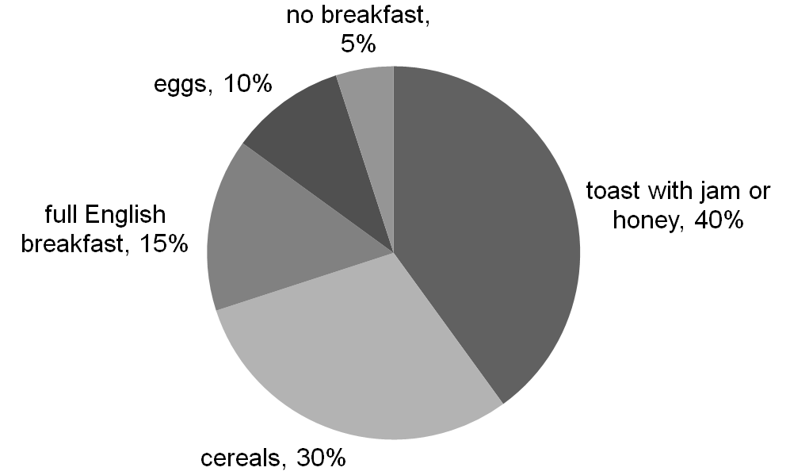

**Write your report. Use the plan to help you.**

**Paragraph 1:** Explain the purpose of the survey.

**Paragraph 2:** Analyse the results of the survey.

**Paragraph 3:** Write your conclusion and make a recommendation.

Mark: ___ / 15

TOTAL MARKS: ___ / 40

Challenge!

1. Complete the text with the correct form of the words in brackets.

Are bats blind?

Actually, bats aren’t blind – but their eyes are 1____________ (poor) developed. However, since they often live in darkness, good eyesight 2____________ (not need). If you were a bat, your way of experiencing the world 3____________ (be) very different from that of most mammals. Over millions of years, the 4____________ (necessary) of living in the dark 5____________ (cause) bats to develop the 6____________ (able) to use echolocation to build up a picture of their environment. High-pitched noises are made by bats when they 7____________ (fly), and, 8____________ (amaze), they collect the information which 9____________ (create) by their own sounds and use this information to locate objects on their journey. Their reactions depend on the 10____________ (situate) they are in. A zoologist told me that he had seen horseshoe bats catching moths in the dark as they flew past them. They could sense the delicate movement of an object – in this case a moth’s wings – by using echolocation.